

**TEACHING NOTE**

**Seepia Games: Planning a Launch Strategy For a New Collectible Card Game**

**SYNOPSIS**

Developers at Seepia Games, a Finnish mobile gaming company, are finalizing a new collectible card game called Permia - Duels II. Before it can be launched, the company’s CEO, Jani Tietäväinen, and Chief Marketing Officer, Jukka Hilvonen, need to decide what platform to launch it on. The choice is a critical one because the very beginning of a launch is crucial for a new game. Early visibility is key to a game’s success: it needs to rise in the rankings lists and achieve a solid player base quickly. Their last game, Pet Shows, was not a success. They didn’t achieve early visibility and players just didn’t find the game. This time, Mr. Tietäväinen and Mr. Hilvonen are determined to get the launch right — the small company can’t afford another failure. However, they know that visibility can be expensive, so they need to come up with a launch that fits the budget of a small firm. The case is about the new product launch within the global mobile gaming industry and it offers an opportunity to discuss several issues related to international entrepreneurship, such as the internationalization strategy of a resource-constrained SME, especially product launch strategy and distribution channel choice, as well as international marketing strategy in general.

This case was prepared by Olli Kuivalainen, Heini Vanninen and Sami Saarenketo at the School of Business and Management at Lappeenranta University of Technology (LUT), Finland. The case is developed solely as the basis for class discussion and not as endorsement, source of primary data, or illustrations of effective or ineffective management. The authors wish to thank Seepia Games, especially Jani Tietäväinen and Jukka Hilvonen, for their co-operation, as well as Becky Reuber for her comments and feedback.

**CASE OBJECTIVES**

The case can be used in courses on international entrepreneurship, international strategy/international business strategies (of SMEs), international marketing, and software business to attain the following learning objectives in such a way that, after the successful casework, a student is able:

* To assess possible international opportunities for a new product launch in the case of a small resource-constrained digital product-based company (mobile video games, application startups, etc.) which is operating by default in a global market
* To analyze the available distribution channels and role of distributors and/or partners, i.e. various platforms, for the success of internationalization
* To explore the role of standardization and adaptation in entrepreneurial international marketing strategy
* To theorize the choice of internationalization strategy (or internationalization pathways) for a small resource-constrained digital product-based company (mobile video games, application startups, etc.)

The case can be used in undergraduate, postgraduate and executive-level programs in courses on, for example, the following topics:

* Product launch strategy
* Internationalization strategy (born global or traditional internationalization strategy)
* International marketing strategy (standardization or adaptation), especially distribution strategy
* Business model choice

This teaching note includes a structured plan for teaching this case in a course on international entrepreneurship/internationalization of SMEs.

**ASSIGNMENT QUESTIONS**

In general, the question to be answered is: “What are the best options for Seepia Games in launching Permia - Duels II?”

In deciding on a launch option, there are a number of considerations, but as a starter an effective case discussion could focus on questions explicitly given in the case study:

1. Should Permia - Duels II be launched on an independent platform or a mainstream platform, and which one(s)?
2. Should Seepia Games pursue a gradual expansion strategy or enter many markets simultaneously? How should these countries be sequenced?
3. Is there a need to adapt the international marketing strategy of the game to foreign markets or can Seepia Games follow a standardized marketing strategy?

The case could also be seen as containing other broad questions related to the international business or marketing strategy of the company, such as: “What is the business model Seepia Games should select for its new game?”

**TEACHING PLAN (FOR A 60-MINUTE CLASS)**

|  |  |  |
| --- | --- | --- |
| 1. | Should Permia - Duels II be launched on an independent platform or a mainstream platform, and which one(s)? | 15 minutes |
| 2. | Should Seepia Games pursue a gradual expansion strategy or enter many markets simultaneously? How should these countries be sequenced? | 15 minutes |
| 3. | Is there a need to adapt the international marketing strategy of the game to foreign markets or can Seepia Games follow a standardized marketing strategy? | 15 minutes |
| 4. | Wrap-up and conclusion | 15 minutes |

**ANALYSIS**

Seepia Games case is partially a context-specific case (along with a number of other digital or Internet-based firms) but there are several issues that need to be considered in relation to a general launch strategy that is applicable to all types of products. Although the questions listed above are to some degree intertwined, it is suggested here that it might be useful to start the analysis by focusing on the first obvious decision built into the case study, that is, the launch platform choice and the distribution strategy in general:

1. ***Should Permia - Duels II be launched on an independent platform or a mainstream platform, and which one(s)?***

The case is framed between the choice of two possible types of distribution channels, i.e. manufacturers’ (or operation system providers’) platforms and other “independent” platforms. Naturally, distribution coverage strategy could be very selective and inclusive (and everything in between) in the case of the platform choice. It is important to note that in this industry some platforms require exclusivity or are willing to support the game company more if they are willing to provide the exclusivity. You might take a note on AppCampus program, which provided funding but which restricted Seepia Games to providing the game only within the Windows Phone platform for a certain period of time.

An alternative way to ask this question to elicit more answers and start the conversation rolling:

* *Is there anything specific in the way the mobile gaming application business is conducted? How is the value capturing and value sharing done in this business?*
  + *E.g. Google Play vs. independent platform such as Kongregate?*
  + *Potential use of the publisher?*
* *What kind of challenges does this create for Seepia Games and for their platform choice decision?*

Students could actually start their assignment by considering all the possible channels (and platforms) and their pros and cons. The instructor could mark down these features on a white board or flip chart, for example, and eventually ask students to provide a justified choice of the platform(s). This could be followed by a joint evaluation of the consequences of each choice. One issue that may come up is why Seepia Games would not just aim to publish the game on all the platforms. This would — in theory, at least — increase the potential target market size, and for the freemium games it is important to get a large player base to make game purchases advantageous for those players who want to do better than average players[1]. However, even if this sounds tempting (and it may be a long-term target), it is a costly exercise which requires resources. This dilemma may provide a basis for an interesting discussion in the class.

Although there are many points that are likely to be identified and that could be discussed in more depth, we recommend that an instructor pay attention to the consequences of this platform choice for the other decisions that need to be made. In this business setting the platform choice can be seen as a choice of entry mode and it may lead a company to use a certain business model in its subsequent operations.

**2. Should Seepia Games pursue a gradual expansion strategy or enter many markets simultaneously? How should these countries be sequenced?**

Discussion of this question can be leveraged from the previous discussion. If the students have chosen to use a number of platforms at the same time, and the platforms have in practice “global reach,” then it may be that some student groups are suggesting entering many markets at the same time. However, it is quite clearly indicated in the case that a gradual, one-or-two-countries-at-a-time strategy may fit Seepia Games better because of resource constraints, i.e. lack of required marketing investments for making the new Permia - Duels II game known among the customer segment.

Essentially, students should perform a strategic management type of analysis of the potential internationalization strategies. Students could actually start their response to this question by considering the pros and cons of the two contradicting internationalization pathways in the mobile gaming context. The instructor could mark down these features on a white board or flip chart, for example, and eventually ask students to provide a justification for the strategy of their choice.

Concepts related to this questions could be the following:

* Gradual (incremental and/or traditional) internationalization strategy: for literature see e.g. Johanson and Vahlne (1977)
* For international new ventures (INVs) and Born Global firms see e.g. Oviatt and McDougall (1994); Bell, McNaughton, and Young (2001); Knight and Cavusgil (2005); Kuivalainen, Saarenketo, and Puumalainen (2012a); Coviello (2015)

In theory, the question is about choosing between the two “extreme” international pathways, traditional and born global pathway. In international marketing literature the market scope strategies are often described as “waterfall” and “sprinkler,” and these concepts can also be introduced to students (see Exhibit 2 for ideas regarding this).

Other elements that may come up from INV and born global literature are factors which enable a firm to follow early and rapid internationalization. The drivers behind this type of behaviour have been studied extensively and include, for example, global mindset, global niche strategy and a number of enabling resources and capabilities (see e.g. Knight & Cavusgil, 2004; Kuivalainen et al., 2012b; Nummela, Saarenketo & Puumalainen, 2004). Some other issues that can be discussed are international experience, ability to gain sustainable competitive advantage in international markets, possibility to get right partners, growth management, and financing strategy for growth (see Exhibit 2 for ideas regarding this). “Need for speed” may come from a unique product which should conquer the markets before the competitors are able to catch up. Life cycle of the industry and product may also have an effect on the decision, and in the case of Seepia Games one important aspect is the existing heavy competition as the industry has matured.

The last part of the question “**How should these countries be sequenced?”** means that students can also be directed towards an evaluation of the attractiveness of various markets. The case description contains ideas of market size and gives some hints of the market characteristics and potential customer characteristics. This possible direction of the debate has close links to Question 3. The systematic marketing selection guidance can be found in most international marketing textbooks (e.g. Hollensen, 2001). If this is relevant, the instructor can also direct the discussion towards market research and the availability of secondary information. This case description has numerous references (also see Exhibit 2 for ideas).

**3. Is there a need to adapt the international marketing strategy of the game to foreign markets or can Seepia Games follow a standardized marketing strategy?**

International marketing strategy analysis can include all the elements of the marketing mix, even though distribution strategy may already have been discussed in Question 1. If the business model issue has not come up earlier this issue may also be linked to a number of elements of marketing mix. For example, when the product is sold through a platform, the platform often manages the payment and takes a premium from the end customer price as described in the case study.

In the mobile gaming industry, at least, the language is adapted for major geographical markets (and language areas). This is rather easy to do and many solutions for this exist. This is something that Seepia Games already handles well. In some large markets, especially in Asia, more adaptation is needed for a successful outcome. The well-known examples are China and Japan. In China there are hundreds of platforms available and choosing the right platform on the basis of the targeted player segment is important. Furthermore, billing systems may be different than in other countries and so a local partner for localization of the whole model (even the looks of the game characters) might be required. If there are international students in the class, the instructor could ask students to share their experiences on mobile gaming in their home countries.

From a marketing perspective the case can be used (beyond the current question) to consider how to do marketing and gain visibility on a shoestring budget. The key issue is how the potential gamers would find Permia - Duels II, and how the case company is able to differentiate its offering from its competitors. It may make sense to revisit the platform choice discussion and discuss briefly how to cooperate with a platform for marketing activities and then consider what can be done outside the platform. The latter may include social media campaigns, but one interesting issue from the Seepia Games experience is the support the company could and should provide to the gamers within the platform. For example, in Kongregate the company has gained new players by proving help desk-style support for new gamers trying Permia Duels I.

**4. Wrap-up and conclusion**

It is recommended that the concluding discussion start with a short overview given by the instructor. He/she could summarize the discussion by possibly picking up two contrasting strategies presented by the students and discussing how these strategies might affect the direction of the company. It should also be emphasized that although the mobile gaming industry has many context-specific issues that should be considered, this case of international entrepreneurship also touches many important issues that are typical for internationalizing resource-constrained SMEs:

* Even if there might be global opportunities in the industry, resource constraints and other constraints (such as liabilities of newness) affect the internationalization of mobile gaming companies.
* This is even clearer when an industry such as the mobile gaming industry matures. There is more competition and it is very difficult to be seen and heard when large incumbents (such as King, Supercell, etc.) use lots of resources to market their products, both in app stores as well as off-line. For example, Supercell had Clash of Clans commercials in World Cup matches shown live on television in France in 2014.
* This means that even if the global market entry using various mainstream platforms would be technically possible, the smaller companies need to roll out their products on a country-by-country basis following incremental internationalization strategy.
* Another option could be the search for new platforms where there would be less competition. This could be seen happening to Seepia Games with its Permia Duels (I) and Windows Phone, but after this launch competition has increased and/or the Windows platform has lost its market share. A new option with more “blue ocean” type possibilities could be, for example, Apple Watch, as mainstream platforms are highly contested.
* Discussion of international marketing strategy and its standardization and possible adaptation is relevant even in a “global” industry like the mobile gaming industry. Seepia Games representatives were adamant, for example, when pointing out the role of culture and the need for adaptation of the games to a certain degree, even if they considered their target segment global.

**Exhibit 1:** Images from the world of Permia Duels





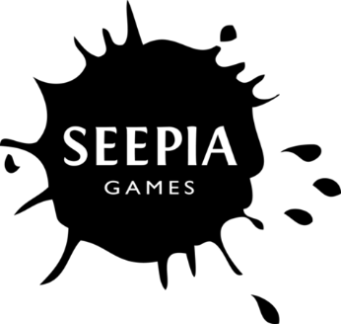 

**Exhibit 2: Various possible slides for the case discussion**

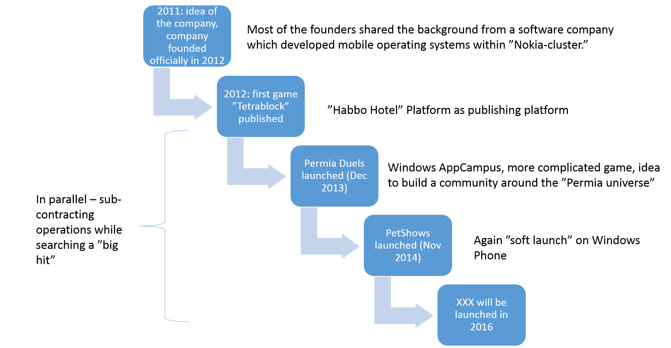

Figure 1: Timeline of Seepia Games



Figure 2: Two “extreme” internationalization pathways (Source: Äijö et al. 2005, see also Bell et al. 2003)

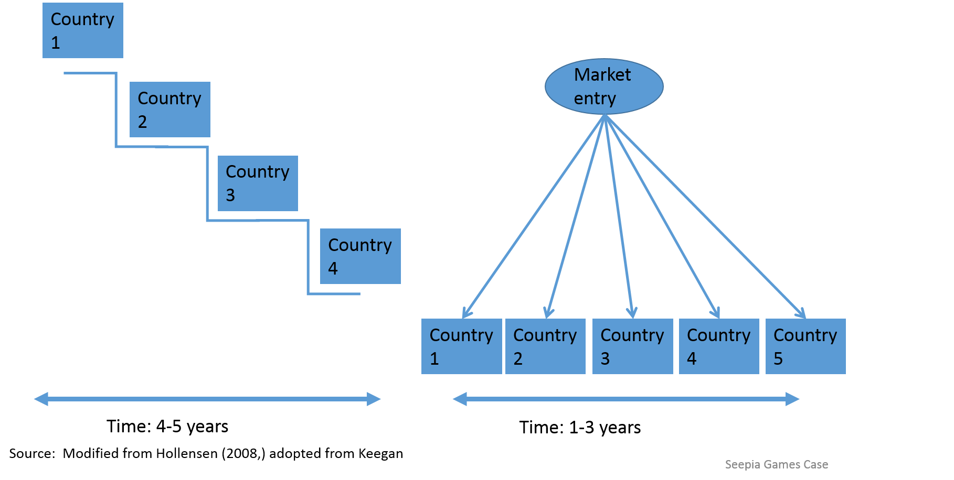

Figure 3: Sprinkler and Waterfall market strategies (Hollensen 2008)

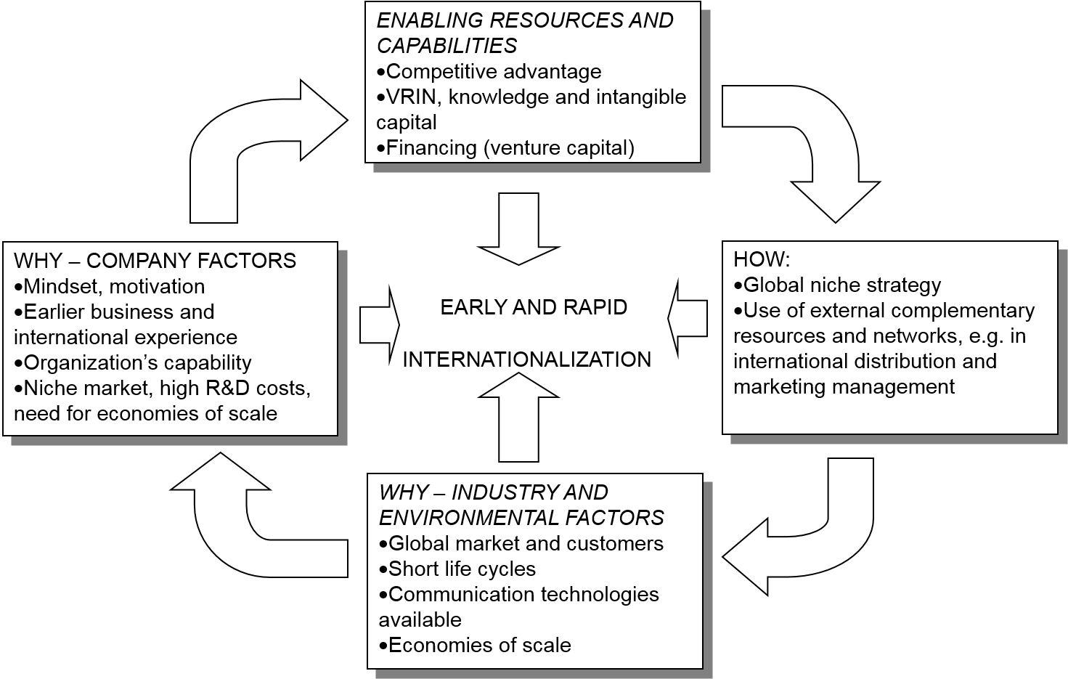

Figure 4: Born globals and International New Ventures – how and why (Source: Saarenketo & Kuivalainen 2001)

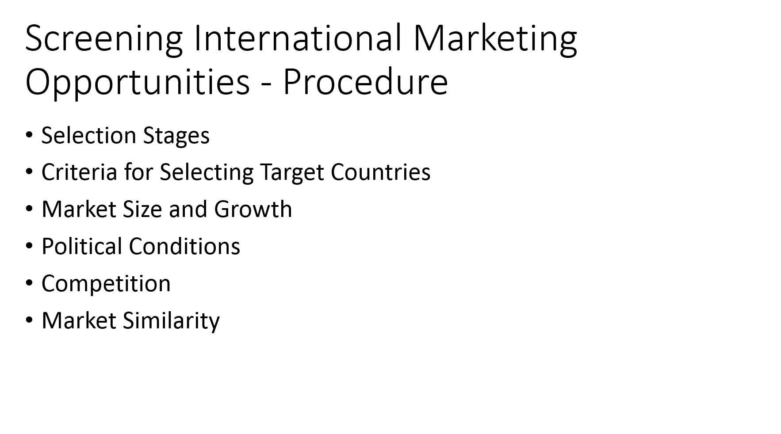

Figure 5: An example of the screening procedure for international markets

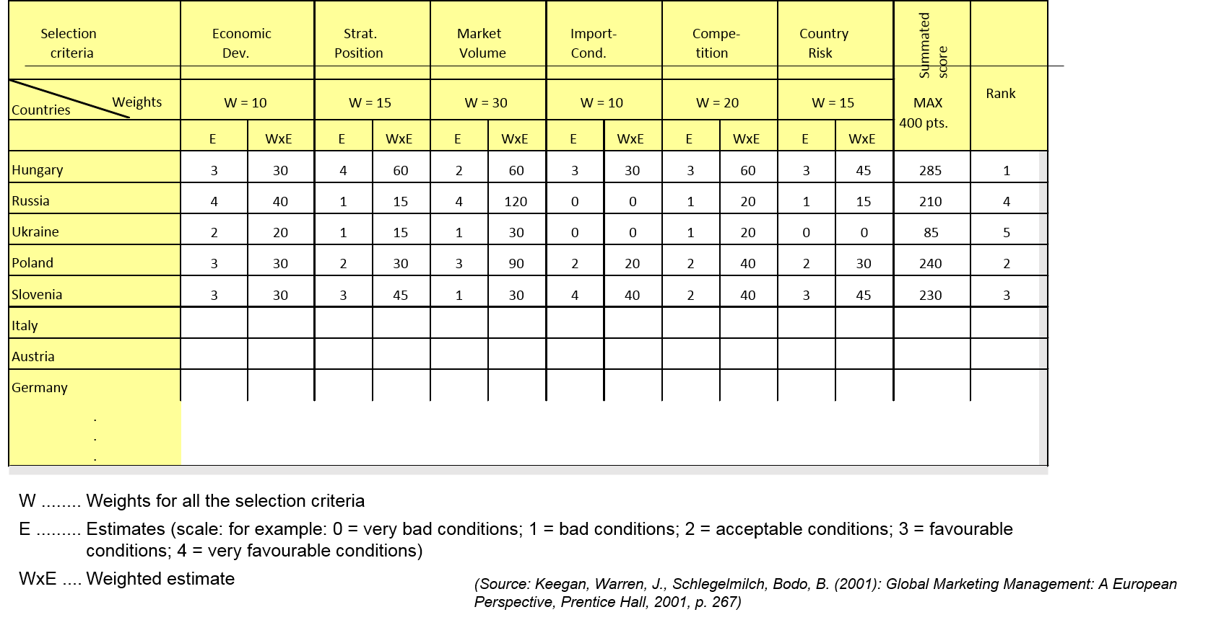

Figure 6: Example of the scoring model for international market selection (Keegan & Schlegelmilch 2001; we also want to acknowledge the help from Rudolf Sinkovics in the preparation of the figure)

**References**

Arroyo-Barriguete, J. L., Ernst, R., Lopez-Sanchez, J. I. & Orero-Gimenez, A. 2010. On the identification of critical mass in internet-based services subject to network effects. *Service Industries Journal* 30 (5): 643-654.

Bell, J., McNaughton, R. & Young, S. 2001. “Born-again global” firms: An extension to the “born global” phenomenon. *Journal of International Management* 7 (3): 173-189.

Coviello, N. 2015. Re-thinking research on born globals. *Journal of International Business Studies* 46 (1): 17-26.

Hollensen, S. 2001. *Global marketing: A market-responsive approach* (2nd ed.), Harlow, England: Financial Times Prentice Hall.

Johanson, J. & Vahlne, J.-E. 1977. The internationalization process of the firm: A model of knowledge development and increasing foreign market commitments. *Journal of International Business Studies* 8 (1): 9.

Knight, G. & Cavusgil, S. T. 2004. Innovation, organizational capabilities, and the born-global firm. *Journal of International Business Studies* 35 (2): 124-141.

Knight, G. A. & Cavusgil, S. T. 2005. A taxonomy of born-global firms. *Management International Review* 45 (3): 15-35.

Kuivalainen, O., Saarenketo, S. & Puumalainen, K. 2012a. Start-up patterns of internationalization: A framework and its application in the context of knowledge-intensive SMEs. *European Management Journal* 30 (4): 372.

Kuivalainen, O., Sundqvist, S., Saarenketo, S. & McNaughton, R. 2012b. Internationalization patterns of small and medium-sized enterprises. *International Marketing Review* 29 (5): 448-465.

Nummela, M., Saarenketo, S., & Puumalainen, K. 2004. A global mindset — a prerequisite for successful internationalization? *Canadian Journal of Administrative Sciences–Revue Canadienne Des Sciences De L Administration* 21 (1): 51-64.

Oviatt, B. M. & McDougall, P. P. 1994. Toward a theory of international new ventures. *Journal of International Business Studies* 25 (1): 45-64.

1. In this sense the freemium business model contains elements of “network effects” products (see e.g. Arroyo-Barriguete et al., 2010 for the "network effects" concept).