

**Seepia Games: Planning a Launch Strategy For a New Collectible Card Game**

Developers at Seepia Games, a Finnish gaming company, are finalizing a new collectible card game called Permia - Duels II. Before it can be launched, the company’s CEO, Jani Tietäväinen, and Chief Marketing Officer, Jukka Hilvonen, need to decide what platform to launch it on. The choice is critical, because the very beginning of a launch is crucial for a new game. Early visibility is key to a game’s success: it needs to rise in the rankings lists and achieve a solid player base quickly. Their last game, Pet Shows, was not a success. They didn’t achieve early visibility and players just didn’t find the game. This time, Mr. Tietäväinen and Mr. Hilvonen are determined to get the launch right: the small company can’t afford another failure. However, they know that visibility can be expensive and so they need to come up with a launch that fits the budget of a small firm.

In deciding on a launch option, there are a number of considerations:

1. Should Permia - Duels II be launched on an independent platform or a mainstream platform, and which one(s)?
2. Should Seepia Games pursue a gradual expansion strategy or enter many markets simultaneously? How should these countries be sequenced?
3. Is there a need to adapt the international marketing strategy of the game to foreign markets or can Seepia Games follow a standardized marketing strategy?

In general, the question to be answered is: “What are the best options for Seepia Games in launching Permia - Duels II?”

**Company Background**

Seepia Games was founded in 2012. Currently (February 2016) it has six full-time employees and there are between one and two trainees at any one time. Seepia Games’ strategy is to focus on its own game development, although they have also been doing outsourced work for other companies to gain revenue. In 2015, the turnover was around €100,000, the majority of which came from contract work. The company has released three games so far.

At first, Seepia Games aimed for a more mainstream audience and released a Tetris-like game called Tetrablok in 2012. By using this rather small exclusive channel the game reached about one million downloads, of which a few thousand were actually paying customers. (The game was a so-called free-to-play game, but as faster advancement was possible with small investments, the business model can be described as “freemium.”) Most of the players of Tetrablok were from Spanish- and Portuguese-speaking countries (Habbo Hotel was hugely popular in Brazil, for example) but most of the money came from Europe, for example, from France.

Then the avid gamer founders found a potential niche in the online and mobile gaming market: collectible card games. This led them to release a free-to-play multiplayer card game with in-app purchases, Permia Duels, in December 2013. During the first year of the

This case was prepared by Olli Kuivalainen, Heini Vanninen and Sami Saarenketo at the School of Business and Management at Lappeenranta University of Technology (LUT), Finland. The case is develop solely as the basis for class discussion and not as endorsement, source of primary data, or illustrations of effective or ineffective management. The authors wish to thank Seepia Games, especially Jani Tietäväinen and Jukka Hilvonen, for their co-operation, as well as Becky Reuber for her comments and feedback.

game more than 800,000 people played this game and in early 2015 the number of people who had downloaded the game was approximately one million. The development of Permia Duels was funded by AppCampus, which was a mobile application development program jointly funded by Microsoft and Nokia. Permia Duels was therefore originally launched to Microsoft Windows Phone platform. The AppCampus support meant that the game gained visibility in Windows phones but as Microsoft’s mobile ecosystem is smaller than Android’s or Apple’s, the overall market potential was predominantly smaller during the exclusivity agreement period. However, this meant there was less competition for mobile collectible card games in Windows mobile platform and for a certain period of time — approximately six months — the game was number one in its segment in the whole world (when the downloaded statistics are considered). Many users game from Brazil and the U.S.; Russia was also surprisingly big. Other platforms are still being planned for this game.

Their latest release, Pet Shows, in Windows Phone platform, was for a more mainstream audience, but this time targeted specifically at children. The game was originally aimed at the Habbo Hotel platform, but when Habbo Hotel’s game site was closed down the development of Pet Shows was finalized by using the AppCampus instrument again. The launch strategies and timelines for each of these games are summarized in Table 1. These very different kind of games have been released with different kinds of launch strategies and successes.

Table 1 Seepia Games’ games and their launch strategies

|  |  |  |  |  |
| --- | --- | --- | --- | --- |
| **Game** | **Platform** | **Launch date** | **Launch success** | **Current status** |
| Tetrablok | Habbo Hotel | Late 2012 | More than one million downloads, with a few thousand paying customers. Most users were from Portuguese- and Spanish-speaking countries, where Habbo Hotel was very successful. | Habbo Hotel closed down its “partner game application section” in early 2014 and so lost the capacity to collect in-game revenue. Modifying the game for other platforms to gain back this capacity was considered too big an investment and so the game was closed down. |
| Permia Duels | Windows Phone (first) | December 2013 | 45,000 downloads in the first month. Eventually about 900,000 during the first 18 months (approx. 3,000 from Finland). Germany and the U.S. were seen as potential key markets for this type of game. There were an unexpectedly large number of gamers from Brazil, where they did not do any paid promotions. This was likely due to free global “featuring” on the Windows Store for a week or so. | The game is now available in the Windows Store as well as in Kongregate. Windows 10 is seen as an opportunity because the number of devices is much bigger than in just Windows Mobile devices. Apple iOS and Android versions are under consideration. |
| Pet Shows | Windows Phone | November 2014 | 10,000 downloads in the first month. The probable reason for not performing as well as Permia Duels is that Pet Shows received less “featuring” in the Windows Store, even though it participated in AppCampus. | Approximately 31,000 downloads in the first 10 months, 2,500 from Finland. The game is available but not actively developed further. The retention rate is reasonable, but even though there are some active gamers, a very limited number of them have made in-game purchases. |

**The New Product, PERMIA - DUELS II**

Permia - Duels II is a new collectible card game set in a fantasy world of Permia. Its planned target segment is characterized as mostly 25-to-40-year-old male players who are keen on the fantasy world setting and its fascinating and carefully designed graphics. The players can play against each other online as in the previous Permia Duels game. Some of them may have played offline collectible card games. Some of the competitors, i.e. a few games and brands, include Magic The Gathering, Duel of Fate Order & Chaos – Duels Scrolls Shadow Era. Currently the big competitor in the digital world is Blizzard’s Hearthstone (which is estimated to have made about $200 million revenues in 2014).

Permia - Duels II has not been played by any actual players yet. However, it is similar to an earlier Seepia Games’ game, Permia - Duels (see Figure 1),[1] so the company knows that the idea of the game appeals to its target audience. But the new game may need modifications based on player feedback. Screenshots from the new game can be found in Exhibit 1.



**Figure 1: Permia Duels’ artwork**

**The Industry**

The mobile video gaming industry has been in continuous ascendancy in recent years. The growing free-to-play segment has been a front runner in this development, and several hit games, such as Supercell’s Clash of Clans and Rovio Entertainment’s Angry Birds games, have made millions for their producing companies.[2] In 2014, Supercell Games’ revenue was $1.8 billion and its biggest game, Clash of Clans, averaged four million concurrent users (Sullivan 2015). By default the market has low entry barriers (as low initial investment is needed), but as market growth has attracted many newcomers visibility is difficult to gain among large incumbent companies spending lots of money for promotion and thousands of small game producers.

Love it or hate it, it is the mobile video gaming segment which drives growth in the game industry. The mobile gaming (tablet and smartphone) market has been estimated to be worth of approximately $25 billion[3]. Asia as a region is a dominant market and this dominance over Europe and North America, for example, is expected to continue in the near future (Digi-Capita 2015). Table 2 and Table 3 show estimations of the market size in different segments and countries. The estimates are difficult to compare, as different methods of calculating the segments are used. For example, in many market studies mobile gaming is sometimes classified separately in a specific mobile games’ class, but sometimes it is either under “games” (including console and PC games) or “mobile applications.” All in all, according to Newzoo (2015), the three leading mobile gaming countries on the basis of revenue are China, the U.S. and Japan (see Table 2), but the fastest growing markets are India (+75% CAGR), Indonesia (+72 CAGR) and the Philippines (+63% CAGR).

*Revenues*

It is important to understand that in the beginning, many games do not even generate income — first it’s important to get the necessary number of players to return to the game time after time. After that it’s possible to start thinking about monetizing. Thus a good initial target is attracting a big enough base of regular players. In mainstream mobile platforms the generic conversion rate from free users to paying customers has been estimated to be approximately 1.5%.

Most platforms have similar revenue shares: the platform takes 30% of all revenue, and the gaming company gets 70%. Some platforms, such as Kongregate, also offer co-operation, where the platform starts “building success” together with the company. Obviously, this is not a cost-free service, but it means an additional cut of 20% of a gaming company’s share of revenue, leaving it at 50% in total. However, this might be worth trying, as services offered by platform (features and other visibility) are important in achieving the needed amount of players.

All of Seepia Games’ previous games have been free-to-play with in-game purchases. This has been the chosen revenue model, as their targets so far have been attracting as many regular players as possible while not generating as much income as possible. After a solid player base is hooked on the game, income starts growing with time. It would also be an option to charge a fee to start playing the game, and not have any in-game purchases. This would, however, limit the number of people who try the game. On the other hand, many of the gamers who return to the game time after time never do any in-game purchases so again, it is a difficult to choose which approach to adopt. The current estimates of Seepia Games with Permia Duels on the Kongregate platform in Germany is that an average new user brings in approximately 10 cents — the total number of users should be compared with the number of paying and returning customers[4]. It is difficult for a free-to-play game to make enough money if the user base in not large enough.

*Soft launch vs. Official launch*

Mr. Tietäväinen and Mr. Hilvonen also needed to discuss when and where to do a “soft launch” for the game and how to implement the “official launch” after that. “Soft launch” is often used in the testing of a new game. Although the development team have tried their best to produce a polished diamond of a game, nothing beats the feedback from real gamers. After various tests, the games are further developed to better appeal to their target market. For example, if gamers seem to quit playing after a certain level, or many players complain about a specific feature, some drastic changes are usually needed. Seepia Games has implemented soft launch with, for example, Permia Duels by having the game first in Windows Phone platform only, and using the results of this launch in the analysis of the game and its development needs. From the soft launch the company also learns about the demography of the game players (how old they are, there they come from, etc.). With this initial knowledge, they can plan which platforms and publishers to choose for the game in its “official launch.”

Games are never “ready,” but the company needs to decide when the game is ready to be officially launched in the most important market areas. An official launch cannot be done a second time. The impact has to be at a maximum level in the official launch. If the game is not as perfect as possible when people try it for the first time, all efforts were in vain. It requires immense effort to make the players return after a disappointment, even if all the improvements needed are be done. The gaming companies only have one chance to get it right.

However, even after the official launch, games are developed all the time. Even small things may matter. For example, Seepia Games recently changed their menu graphics and with this small change the retention rate of their game Permia Duels improved by 10%. With continuous updates and improvements, the game may achieve better visibility in its platform and more players have the chance of finding it.

**Gaming Platforms/publishing partners to choose from**

One of the most important decisions for the gaming company is which platform to use for publishing the game. The optimal platform has a large player base that fits the demographics of the target group of a certain game. The player demographics vary between different gaming platforms, and thus attention should be given to choosing the correct gaming platform. However, choosing the platform is not an easy task, as there are vast differences between the various platforms and platforms may also be in different stages of their life cycle. Mr. Hilvonen, the Chief Marketing Officer of Seepia Games, is suggesting using an independent platform when publishing Permia - Duels II but Mr. Tietäväinen worries that none of the independent platforms would generate enough income to keep paying the salaries of the development team. Therefore, they need to discuss this matter thoroughly before the decision can be made.

*Independent platforms*

As mentioned above, one of Seepia Games’ first game releases, Tetrablok, was launched in an independent gaming platform called Habbo Hotel. Habbo was a social networking service and online community aimed at teenagers. Habbo had its own in-game virtual currency that could be purchased using a variety of different services, such as credit card or SMS. Unfortunately for Seepia Games, the owners of Habbo Hotel shut down the partner game option for various reasons some time ago. This meant that Tetrablok lost the platform it was optimized for. Also, Seepia Games’ Permia Duels has been launched in an independent platform called Kongregate, aimed at people who play games regularly. Similarly to Habbo Hotel, Kongregate has its own in-game virtual currency. Kongregate players, many of whom are dedicated to playing, are also good sources of valuable feedback for the game development.

Independent platforms vary by size (amount of players) and player demographics. It is therefore possible to find a good fit for a game that is attractive to a specific type of audience. For example, Seepia Games’ collectible card games is not everyone’s cup of tea, and thus may perform better in a platform with the right type of player base. Independent platforms also have ready-made tools for managing a community of players, and their conversion rate might be better than in general mobile platforms.

However, the downside of independent platforms is that many of them have rather small player bases, and they may also be closed down. For example, as mentioned above, Tetrablok’s story ended when Habbo Hotel’s partner gaming option was closed in 2014. (All in all, Habbo Hotel has lost users and many countries’ sites have been closed down.) They may also host only certain kind of games, such as games played online instead of mobile, which may mean development needs for the game and restrictions for its use. For example, Kongregate players play online games, and mostly during the weekend only.

*Kongregate (*[*http://www.kongregate.com/*](http://www.kongregate.com/)*), a thriving community for active and engaged gamers*

Kongregate is a host to approximately 100,000 free online games. The portal also offers social features that allow gamers to communicate with other gamers from around the world via chat rooms and forums, and to compete with friends to get the top scores. Kongregate reaches more than 21 million unique users monthly. The demographics lean heavily male (approximately 80%), with a median age of 19. They are predominantly from North America and northern/western Europe. They tend to be core gamers who own console systems and spend substantial time and money gaming. They seek out competitive multiplayer games to show off their skills and knowledge with other gamers. Game companies can choose to join the Kongregate kreds payments program, which includes some initial promotion to help get players into the new game. Kongregate runs spotlight ads on the site (a minimum of one million impressions free of charge) and if the game gets a high rating they will put it in the Hot New Games section on the front page.

Kongregate shares its revenue with its developers:

Virtual Goods Revenue: Purchases made with kreds in the game are split 70% to the developer and 30% to Kongregate. These splits are of the gross revenue generated — any fees from payment providers are covered in Kongregate’s share of the revenue.

Ad Revenue: Kongregate also shares up to 50% of ad revenue generated on the game’s page. The exact amount varies with the current market and promotions, but generally is between $1 and $2 eCPM (effective cost per thousand impressions) for the developer.

Partner Program: In some cases, if Kongregate thinks they can really take the game big with heavy promotion, they may offer developers the option to switch over to their Partner Program after launch. Games in this class are in a closer relationship with Kongregate, receiving regular and larger promotions and advertising. They operate on a 50%-50% revenue split and in exchange get substantial guaranteed promotion both from Kongregate and GameStop.

*Mainstream platforms*

If the game is for a mobile device, the developers can also choose from “mainstream platforms” such as Apple’s App Store, Google Play for Android and Windows Store, among many other options. The pros of mainstream platforms are the vast numbers of players they are able to reach. For many gaming companies, only a success in a mainstream platform brings in revenues that are enough to support a company.

With platforms for mobile games and applications, the gaming device is always at hand, and players are able to look for new games and play them at all times. However, with vast numbers of players comes intense competition. Thousands of other games are fighting for attention and only a very small percentage of games actually makes it in these platforms.

**Apple App Store, “where the money is”**

At the moment iOS is the single biggest app store, followed by Google Play and China Android (Digi-Capital 2015). More than 300,000 apps are being downloaded to Apple’s App Store every year. In the U.S. App Store, the number of apps available is reaching two million and growing all the time. Although it may have a huge number of users, every app competes with millions of others for the attention of the consumer. For mobile games in particular it is a challenging marketplace, as that is the most popular and crowded category in the store. There is no exact demographic of a typical consumer of Apple’s App Store, as virtually everyone with an iOS device is a possible consumer.

*Achieving visibility in the platforms*

Seepia Games, as a small company with very scarce resources, has not used any money for customer acquisition (paid advertisements in platforms), but has still attracted more than two million downloads. How has this small gaming startup achieved these figures? One reason for this success has been that firstly, they have developed a game with little competition in its field and thus achieved a number one position in the top list for card-collecting games. Achieving a high ranking in any ranking list secures the game the needed attention of potential players. In addition to good ranking, small gaming companies should aim for being featured inside the selected gaming platform. For a small company this is difficult, but finding a right platform can help in achieving this, as smaller platforms are often more willing to negotiate about features. If the gaming company is able to develop good relationships with the platform, and the game shows potential, it is given more time as a featured game, which will again bring more visibility.

The best marketing for any game is good ratings from the players who have tried it. This sends a message to other interested players as well — a game with a good rating is most probably of good quality and worth the try. Other marketing means in platforms include “optimizing” the game’s icon — the text and the pictures and videos that are used in the game’s introduction. These are often not just “screen shots” of the actual game but enhanced versions of the actual game to lure interested players.

**Global or Sequential Launch**

*Shooting for the stars with a global launch or playing it safe with a market-by-market approach?*

By default, some of the platforms offer a great possibility to conquer a market with a new type of game in a very short period. This might provide a huge opportunity for a company with a new innovative game. The net effect may be that the diffusion of the game is rapid and it reaches the required critical mass for a free-to-play game to gain enough players to increase the attractiveness of in-game purchases (as the purchases should give an advantageous position for a buyer over the larger population of players who do not purchase additional items).

However, it may be that the company does not have the resources to conquer all the markets simultaneously by following so-called born global strategy, hence it may seem lucrative to try to enter one geographical market at the time. Games can actually be released in different market areas with a very detailed schedule, for example in a new market area each day. It might be wiser for a small operator not to launch the game globally immediately, as that would require a huge marketing effort to be worth it. With a market-by-market launch it is easier to concentrate on one market at a time, both with marketing efforts and a follow-up of the statistics. With this approach it is also possible to achieve a better visibility in the various ranking lists. With a global launch it is very hard to achieve a good ranking anywhere. And without a good position in the ranking, the players may not find the game.

Market-by-market launches, especially in the soft launch stage, also help the gaming company understand where the most potential is located. Gaming statistics are rather easy to follow, as they are available from the various platforms. The statistics tell how many downloads there are, and from where on the globe these downloads originate. Also, Google Analytics can be used to complement the game statistics. By analyzing these statistics, Seepia Games has found out that, for example, Permia Duels has been popular in Brazil (via Windows Store platform). Seepia Games expected to have more players from other countries, such as from Germany, but due to the unpopularity of Windows Store in the market, it has managed to attract only a minimal amount of players.

**Standardized Strategy or Strategy Adapted to Local Markets?**

In different countries mobile gaming and online gaming have different characteristics. The harsh reality is that some markets may be difficult to enter without large resources and careful adaptation of the product and the strategy. For example, Japan is dominated by Japanese players, so the usual suspects like Supercell, etc., have been competing just to stay in the top 10 on the app store charts (Mense 2015).

The managers need to consider carefully what the required level of marketing strategy adaptation is. In mobile games it is easy to localize the language in a game. Seepia Games learned how to do this when Tetrablok was made available in various localized Habbo Hotels. Furthermore, Pet Shows has been translated into Portuguese and Finnish, and Permia Duels has more than 10 language versions. These include the large European languages (German, French, Spanish, Italian) as well as Portuguese (as the company has had Brazilian visibility based on Habbo Hotel’s success there), Chinese and Russian. Jukka Hilvonen has already had some discussions with potential Chinese distributors and he has received some comments that the game looks a bit “Western.” However, both Mr. Tietäväinen and Mr. Hilvonen see that Fantasy World can be seen as a universal concept. According to their knowledge, even the first free-to-play game was a collectible card game in Taiwan.

The other dimension which has to be considered is the channel, as the competitive position of the platforms differ. Even if in the Western countries it is Apple’s iOS which is the platform making the most money, it is Android which dominates in China. With a dominant position in downloading volumes in 2014, Android made more money than iOS in China in 2014 (Digi-Capital 2015). However, iOS remains the easiest mainstream app store for monetization per download, as more than two downloads on Google Play and over eight downloads on Chinese Android app stores are required to capture the same amount of money as one iOS download would bring in (Digi-Capital 2015). In markets like China, billing, collecting payments, localizing the game and protecting one’s intellectual property rights can also be an issue (Mense 2015) and local partners may be required. In China there are hundreds of possible channels for distribution of mobile apps. The key platforms for distribution of Android games in China are Baidu, Qihoo, Tencent, but device-selling branded stores like Xiaomi, Lenovo and Huawei can also be used, for example (Mense 2015).

There can also be surprises in the market size. Newzoo (2015) expected that mobile games would generate $30.3 billion internationally in 2015. In comparison, their forecast for console games was $26.4 billion. Many sources have pointed out that 2015 could have been the year when mobile gaming became the biggest gaming segment. For example, research agency Digi-Capital (2015) has predicted that whereas mobile games would take $3 of every $10 spent by gamers on software in 2015, that figure would go up to $4 out of every $10 by 2018 (and the rest would be divided by other platforms). However, regional differences occur in this development. In North America, consoles have still been dominant and Newzoo’s forecast for console game sales for 2015 was approximately $11.1 billion when mobile games would generate “only” $7.2 billion in this particular market.

In addition, the money spent for mobile games seems to vary a lot according to the country. Money spent on average per month seems to be much higher in Japan and South Korea than in the U.S., for example (Eedar 2015). In this study Japan had the highest percentage (8%) of heavy spenders (greater than $100 a year) but at the same time the country also had the highest percentage of non-spenders (61%). In contrast, the U.S. had the lowest percentage of non-spenders (50%) but a fairly high percentage (45 %) of moderate payers, in other words, gamers who spend under $100 a year on mobile games (Brightman 2015). These types of issues also make pricing decisions difficult.

**Dilemma**

The game will be ready to see the light of the day in just a few weeks, and the strategy has to be flawless. From experience, Mr. Tietäväinen and Mr. Hilvonen know that the beginning of the launch is crucial for any new game. If the new game does not rise in the ranking lists and achieve a solid player base, the chance for any success is gone. For example, their third game, Pet Shows, never had a real chance at success since they hadn’t planned the launch carefully and players just didn’t find the game. This time they are determined to get every step of the launch strategy right: the small company can’t afford another failure. Thus, Mr. Tietäväinen and Mr. Hilvonen have been going through the launches of all their previous games and recalling the lessons learned.

These experienced game company managers already know that the ultimate challenge in the gaming business is the visibility of the game. Every new game launch competes with thousands of other games and applications that are launched on a daily basis in various platforms. Capturing a gamer’s attention is a challenge that gets more and more difficult. Large and successful gaming companies, such as Rovio and Supercell, can purchase visibility with a hefty price, but the typical smaller gaming company cannot afford to compete with similar means. While Supercell, for example, is using millions to market their games, the entire turnover of Seepia Games is approximately €100 000. The options for most of the online/mobile game companies include other actions in the quest for visibility, such as featuring in the platform (platform chooses to highlight the game where every player in the platform sees it).

All the choices that Mr. Tietäväinen and Mr. Hilvonen need to ponder in the launch strategy have to be made keeping in mind the goal (visibility) and the scarce resources of the small company. Before the dollars come pouring in, careful planning is called for. However, after summing up the different options in relation to the launch of Permia - Duels II, Mr. Tietäväinen and Mr. Hilvonen are turning to the decision phase and starting to prepare the best possible launch strategy for their next meeting with the whole development team.

|  |  |  |  |
| --- | --- | --- | --- |
| **Table 2:** Market size estimations in gaming software and mobile gaming markets | | | |
| Year | Global games software market1 | | Mobile gaming2 |
| Year | $ billion | Growth % | $ billion |
| 2010 | 29,6 | Not available | Not available |
| 2011 | 30,8 | 4,3 % | Not available |
| 2012 | 31,8 | 3,3 % | Not available |
| 2013 | 29,9 | -6,1 % | 17,5 |
| 2014 | 29,8 | 0,0 % | 25 |
| 2015 | Not available | Not available | 30,3 |
| 1The value of the games software market consists of the total revenues generated through the sale of console games and PC & Mac games (Source: MarketLine 2015). | | | |
| 2Mobile gaming estimates consist of both gaming by using smartphones and tablets (Source: Newzoo, 2014). | | | |

|  |  |  |  |  |  |
| --- | --- | --- | --- | --- | --- |
| **Table 3:** TOP COUNTRIES BY MOBILE REVENUE 2015 (estimated) | | | |  |  |
| Rank | Country | Estimated Revenue - $Million (US) | Rank | Country | Estimated Revenue - $Million (US) |
| 1 | China | $6,500 | 11 | Russia | $336 |
| 2 | Japan | $6,184 | 12 | Brazil | $319 |
| 3 | USA | $6,016 | 13 | Mexico | $298 |
| 4 | South Korea | $1,850 | 14 | Italy | $298 |
| 5 | United Kingdom | $1,009 | 15 | Spain | $229 |
| 6 | Germany | $819 | 16 | India | $227 |
| 7 | France | $520 | 17 | Turkey | $205 |
| 8 | Australia | $518 | 18 | Thailand | $172 |
| 9 | Canada | $507 | 19 | Indonesia | $168 |
| 10 | Taiwan | $413 | 20 | Hong Kong | $160 |
| *Source: Newzoo Global Games Market Report 2015* | | | |  |  |

**References and additional information:**

Apple App Store statistics. Available at: <http://www.pocketgamer.biz/metrics/app-store/>

Brightman, James (2015). Mobile games market worth $25bn – EEDAR. Source: <http://www.gamesindustry.biz/articles/2015-11-12-mobile-games-market-worth-usd25bn-eedar> Accessed 10.2.2016

Digi-Capital (2015). Source: <http://www.digi-capital.com/news/2015/05/games-leaders-to-dominate-45-billion-mobile-games-revenue-forecast-by-2018/#.VrsDWU3UjIU> Accessed 10.2.2016

EEDAR (2015). Deconstructing Mobile & Tablet Gaming 2015. Source: <http://www.eedar.com/reports>. Accessed 10.2.2016

Kongregate gaming platform. Available: <http://www.kongregate.com/>

Mense, Ronan (2015). Mobile gaming in Asia: One size doe not fit all. Source: <http://www.gamesindustry.biz/articles/2015-11-05-mobile-gaming-in-asia-one-size-does-not-fit-all> Accessed: 10.2.2016.

Newzoo (2014) Global Mobile Games Revenues to Reach $25 Billion in 2014 Source: <http://newzoo.com/press-releases/global-mobile-games-revenues-reach-25-billion-2014/#hLl6QVbujqBbM3KW.99>. Accessed: 10.2.2016.

Newzoo (2015) T11 Sept 2015: The Global Games Market: Trends, Market Data and Opportunities  
Available: <http://newzoo.com/keynotes/t11-sept-2015-the-global-games-market-trends-market-data-and-opportunities/#6LoYKoewcCPzwa8h.99> Accessed 10.2.2016

Permia Duels, An In-Depth Review (2015) <http://tradingcardgames.com/review/permia-duels/> Accessed. 6.3.2016

Seepia Games (2015) <http://www.seepiagames.com/> Accessed 10.2.2016

Sullivan, Sean (2015) The most profitable mobile game developers. <http://mmos.com/editorials/the-most-profitable-mobile-developers> Accessed 12.2.2016

**Exhibit 1: Screenshots from Permia – Duels II**

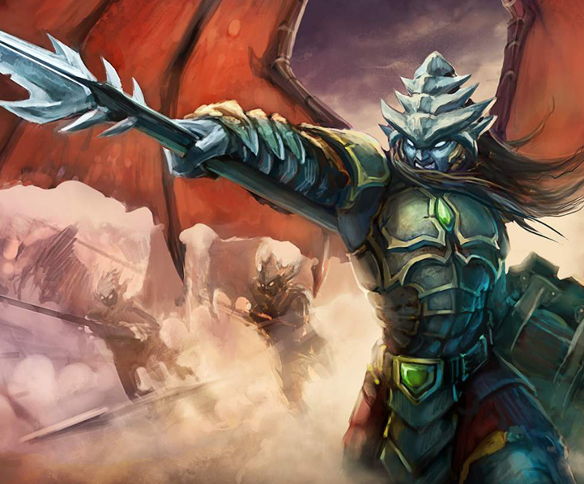

**Exhibit 1a: Card 0016 – Aeros Commander**

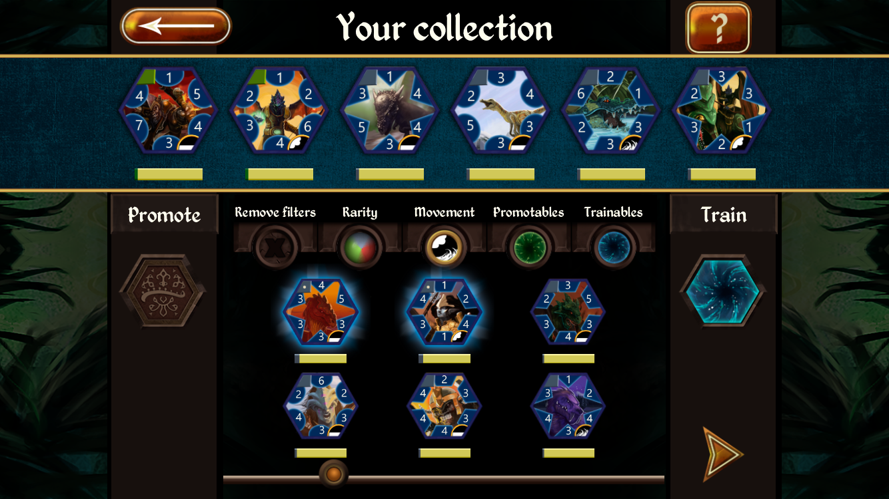

**Exhibit 1b: Simulator Screenshot**

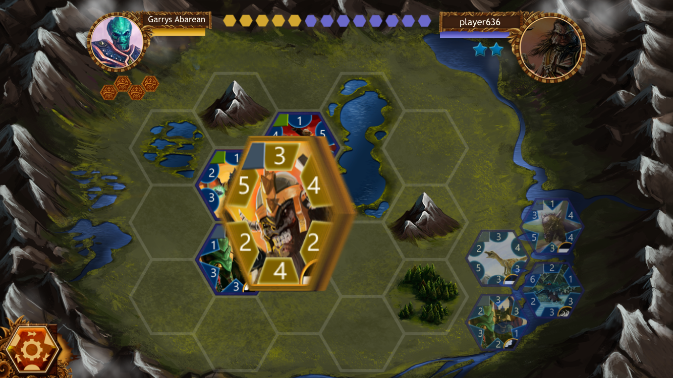

**Exhibit 1c: Simulator Screenshot**

1. For a review of Permia Duels (and how the game works) see e.g. http://tradingcardgames.com/review/permia-duels/
2. There are various estimates of revenues of mobile video games but in a number of studies the most profitable iOS games have been Clash of Clans (launched in 2012, free-to-play); other success stories include Candy Crush Saga (launched in 2012, free-to-play) and Game of War – Fire Age (free-to-play); see e.g. <https://thinkgaming.com/app-sales-data/> and <http://gamasutra.com/view/news/252818/Report_The_worlds_most_popular_most_profitable_iOS_games_are_3_years_old.php>

  
3. A number of 2015 market-size estimations for mobile gaming suggest that the figure is higher than $20 billion or even $30 billion. For example, EEDAR’s report, “Deconstructing Mobile & Tablet Gaming 2015,” which was published in late 2015, assesses the market as being worth about $25 billion by the end of 2015. SuperDataResearch’s (2015) estimation is slightly smaller, i.e. $22.4 billion for mobile gaming in 2015. Newzoo (2014), another international games market research firm, forecast in late 2014 that in 2015 the market could reach the $30 billion threshold. Mobile gaming accounts for approximately one-third of the global games market (www.superdataresearch.com).
4. In the mobile gaming industry it is seen as a good “industry standard” if 40% of gamers who try the game return the next day, 20% after a week, and 10% after a month. After many development rounds in Permia Duels the game seemed to do slightly better than this “industry standard” in Germany.